Project Design Phase-II
Technology Stack (Architecture & Stack)
Date | 30 September 2026
Team ID | SWTID-2026-8331
Project Name | Team Enrollment Confirmation - Import Data using Transform Maps (Spreadsheet)
Maximum Marks | 4 Marks

Team Details
Team Size: 4
S.No | Name | Role | Team
1 | SRIKAVI T | Team Leader | SWTID-2026-8331
2 | ISWARYA S | Team Member | SWTID-2026-8331
3 | YOGASRI S | Team Member | SWTID-2026-8331
4 | KEERTHIKA L | Team Member | SWTID-2026-8331

Project Overview
This project imports team enrollment data from a spreadsheet into ServiceNow using Import Sets and Transform Maps, stores it in a target table, and sends an enrollment confirmation to each team member. It replaces manual data entry with a repeatable, validated import.

Technical Architecture
Example reference: Team Enrollment Confirmation - Import Data using Transform Maps (Spreadsheet). The diagram below shows the local, cloud and external components, data storage and the flow between them.
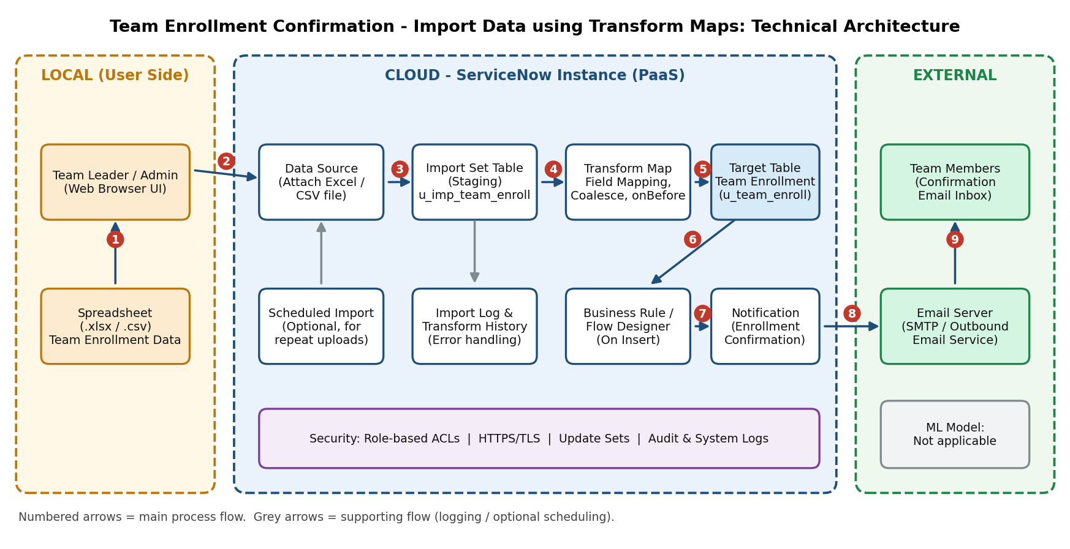

Data Flow
- The team leader / admin prepares the enrollment spreadsheet (.xlsx / .csv) locally.
- The file is uploaded and attached to a Data Source in the ServiceNow instance.
- Load Data copies the rows into the Import Set (staging) table.
- The Transform Map maps columns to fields, coalesces on Team ID and validates values.
- Valid rows are inserted or updated in the Team Enrollment target table; errors go to the import log.
- A business rule / flow fires on insert and triggers the confirmation notification.
- The email server delivers the confirmation to the team member's inbox.

Sample Field Mapping (Transform Map)
S.No | Spreadsheet Column (Source) | Target Field (u_team_enrollment) | Notes
1 | Team ID | u_team_id | Coalesce field (unique key)
2 | Member Name | u_member_name | Direct mapping
3 | Role | u_role | Team Leader / Team Member
4 | Email | u_email | Used for confirmation email
5 | Enrollment Status | u_status | Set to 'Confirmed' by business rule

Table-1: Components & Technologies
S.No | Component | Description | Technology
1 | User Interface | Web UI used by the team leader / admin to upload the enrollment spreadsheet, run the transform and view the imported records. | ServiceNow Web UI (Now Platform), Import Sets and Data Source forms; HTML, CSS, JavaScript (platform-provided)
2 | Application Logic-1 | Data import: the spreadsheet is attached to a Data Source and loaded into a staging (import set) table. | ServiceNow Import Sets, Data Source (Excel .xlsx / CSV)
3 | Application Logic-2 | Transform Map: maps spreadsheet columns to target fields, coalesces on a key field to avoid duplicates, and validates values before insert. | ServiceNow Transform Maps, field maps, onBefore transform script (server-side JavaScript)
4 | Application Logic-3 | Confirmation logic: when a new enrollment record is inserted, an event triggers the enrollment confirmation to the team member. | Business Rule / Flow Designer, ServiceNow Notifications & Events
5 | Database | Staging table (import set) and target table holding team enrollment data (Team ID, Name, Role, Email, Status). | ServiceNow relational database (platform-managed tables)
6 | Cloud Database | Database service hosted with the ServiceNow instance in the cloud. | ServiceNow Cloud instance database (Personal Developer Instance)
7 | File Storage | Uploaded spreadsheet file is stored against the Data Source record. | ServiceNow Attachments (sys_attachment)
8 | External API-1 | Sends the enrollment confirmation email to team members. | SMTP / ServiceNow outbound email service
9 | External API-2 | Optional: lets other systems read enrollment records after import. | ServiceNow REST Table API (JSON) - optional
10 | Machine Learning Model | Not applicable for this project. | N/A
11 | Infrastructure (Server / Cloud) | Application deployed on the ServiceNow cloud instance; the user only needs a browser locally.  Local Server Configuration: Windows / any OS, Chrome or Edge browser, MS Excel to prepare the file.  Cloud Server Configuration: ServiceNow Personal Developer Instance (PDI), admin / import_admin role. | Local (browser) + Cloud (ServiceNow PaaS)

Table-2: Application Characteristics
S.No | Characteristics | Description | Technology
1 | Open-Source Frameworks | ServiceNow is a proprietary platform, so no open-source framework is required. Open standards and formats are used for data exchange and scripting. | CSV, XLSX (Office Open XML), JSON / REST, SMTP, JavaScript
2 | Security Implementations | Role-based access to import tables and target table, secured web access, validation of incoming data, and audit trail of imports. | ACLs and roles (admin / import_admin), HTTPS/TLS, transform validation, audit & system logs
3 | Scalable Architecture | Layered design: presentation (UI), application (import / transform / notification logic) and data (tables). Staging table separates upload from processing so large files can be handled in batches. | 3-tier on ServiceNow platform, Import Sets, scheduled imports
4 | Availability | Application runs on the ServiceNow cloud, which handles hosting, redundancy and failover, so the import service stays available without local servers. | ServiceNow cloud infrastructure (platform-managed)
5 | Performance | Transform runs on the server side in one pass; coalesce prevents duplicate records; notifications are queued as events so they do not slow the import. | Import set batch processing, coalesce, event queue

References
- https://c4model.com/
- https://developer.ibm.com/patterns/online-order-processing-system-during-pandemic/
- https://www.ibm.com/cloud/architecture
- https://aws.amazon.com/architecture
- https://medium.com/the-internal-startup/how-to-draw-useful-technical-architecture-diagrams-2d20c9fda90d

